**Deployment Manual**

* Download the compressed project from the given GitHub link:

**Link:** [**https://github.com/Chuppalatarun/Pizza-Ordering-System**](https://github.com/Chuppalatarun/Pizza-Ordering-System)

* Open STS and import the downloaded file.
* Go to your application properties and change the credentials according to your system.
* The port number we have given is 8094, if this port is busy, change the port number.
* In SQL, type the SQL statements provided by us.
* Run the project as spring boot application as shown in the picture below.

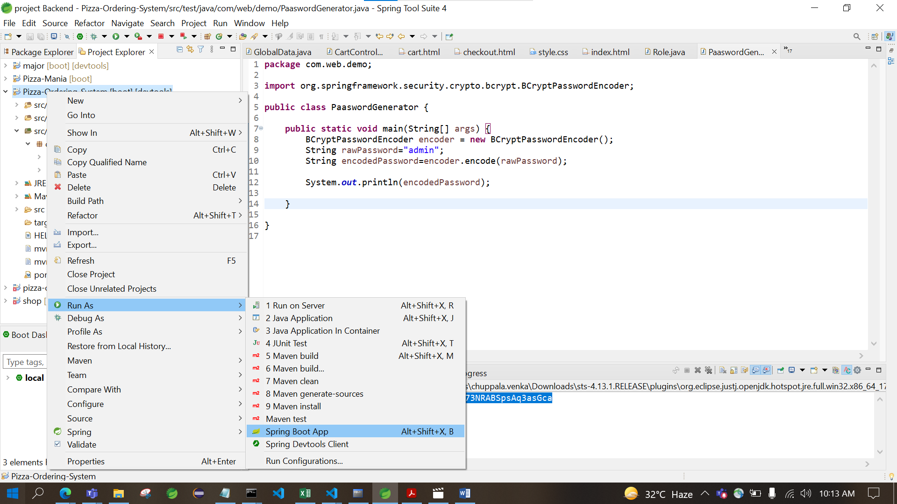

* After clicking, you will get a pop up. Select as shown below.

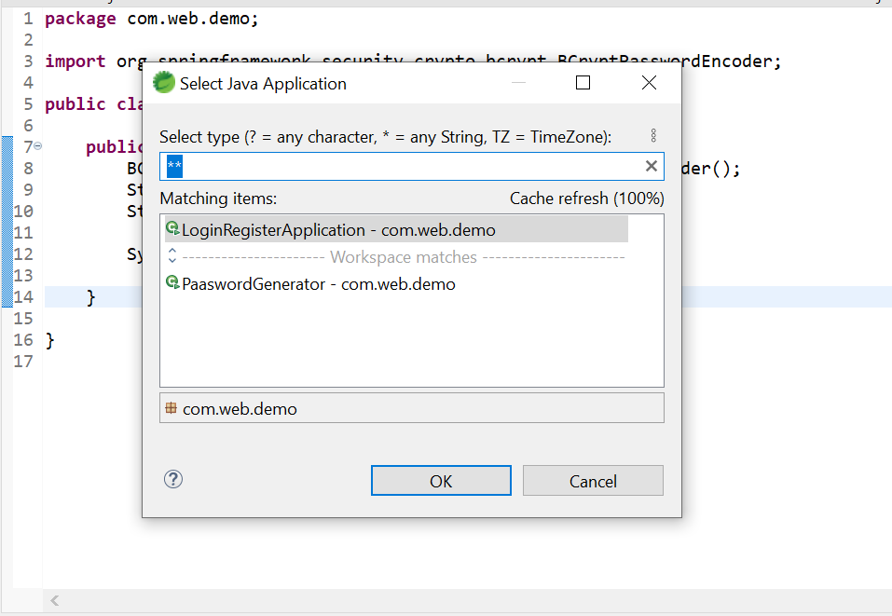

* Once, it shows login registration application has started in the console, open up your web browser and type localhost:8094/ (or localhost: port number/).





* Once it gets loaded, main page of the site gets opened up.

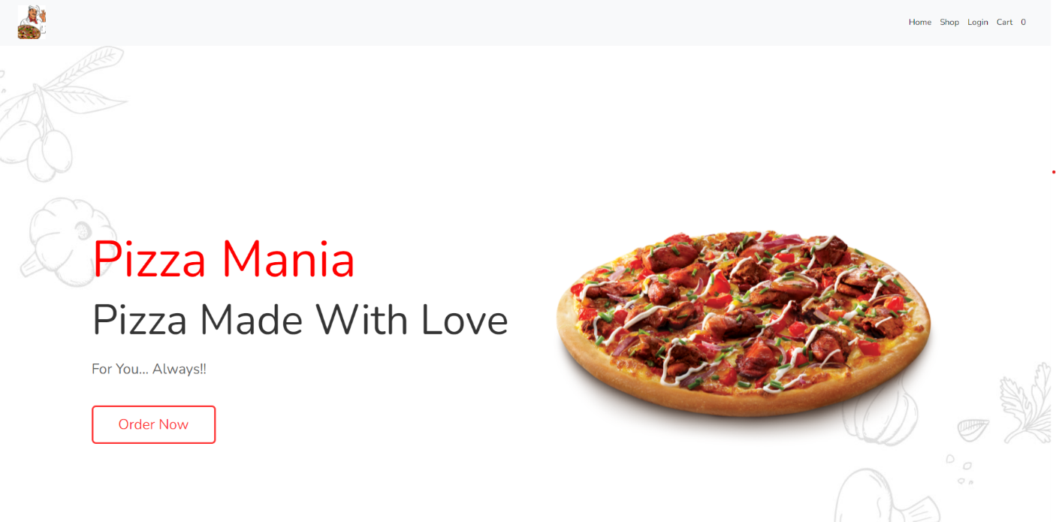

* To login to your account, click login in the navigation bar.

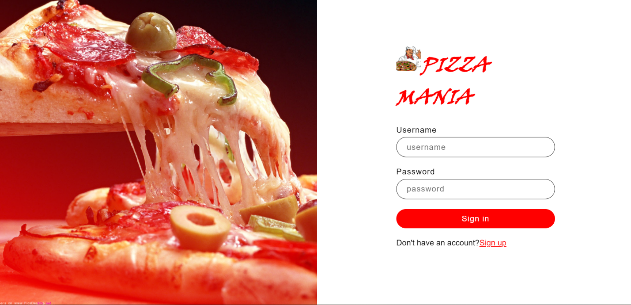

* If you are a first time user, click on sign up and register your account.

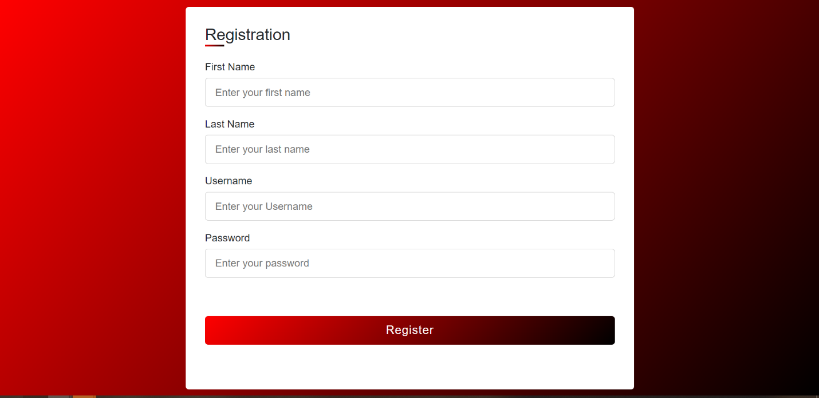

* After successfully logging in, you will get redirected to main page. From there, either click on order now or in the navigation bar, click on shop which will redirect you to shop page where you can see all the products.

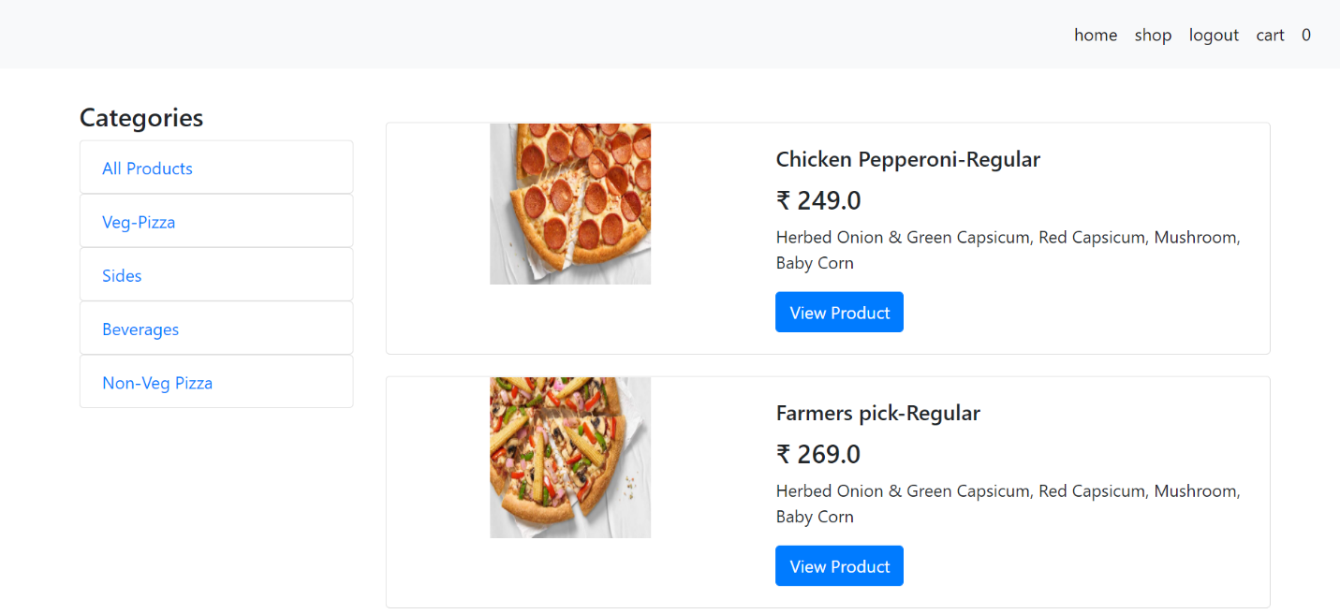

* From there, you can click on view product to see the additional details about the product.

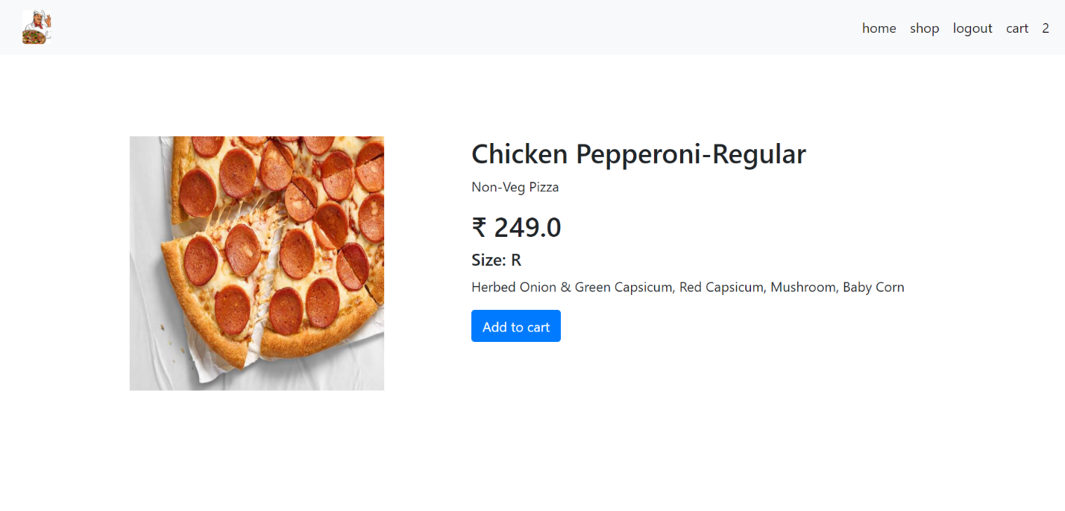

* If you are interested in the product, you can add the product to cart by clicking on add to cart.

When you want to see the cart details, click on cart in the navigation bar. If you are not interested in a particular product you added to cart, you can remove it by clicking on remove item.

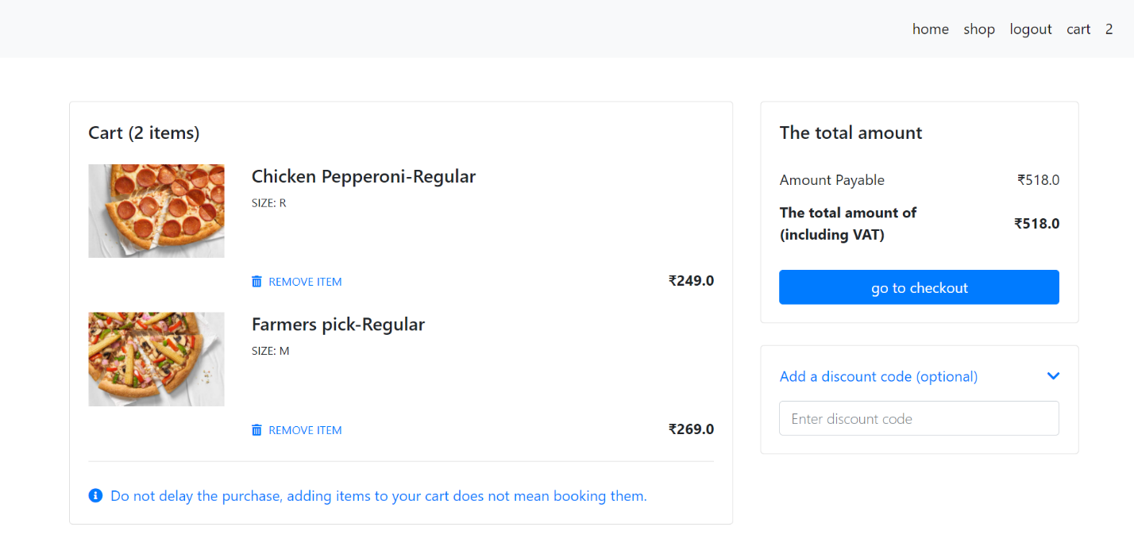

* When you click go to checkout, it will redirect you to checkout page.

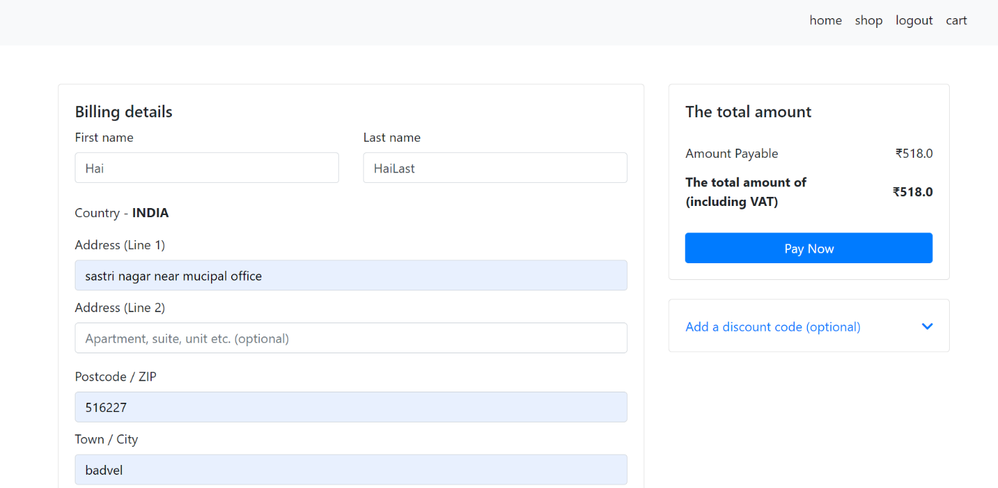

* In the login page, if you give the admin credentials, you can login as admin and will redirect you to admin home page.

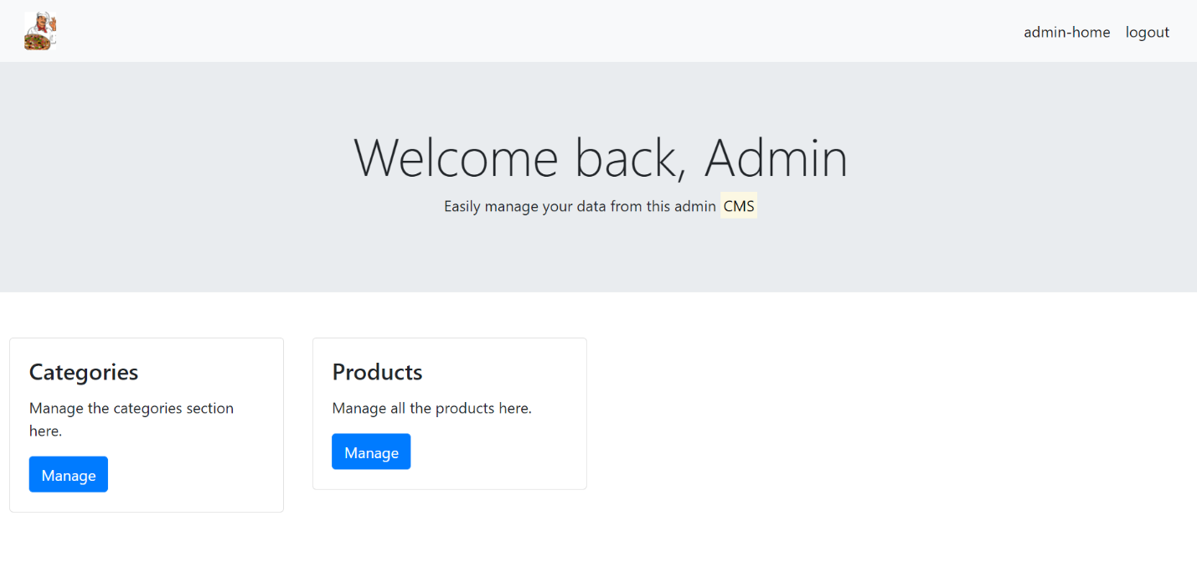

* If you click manage in the categories section, you can add, delete and update different categories.

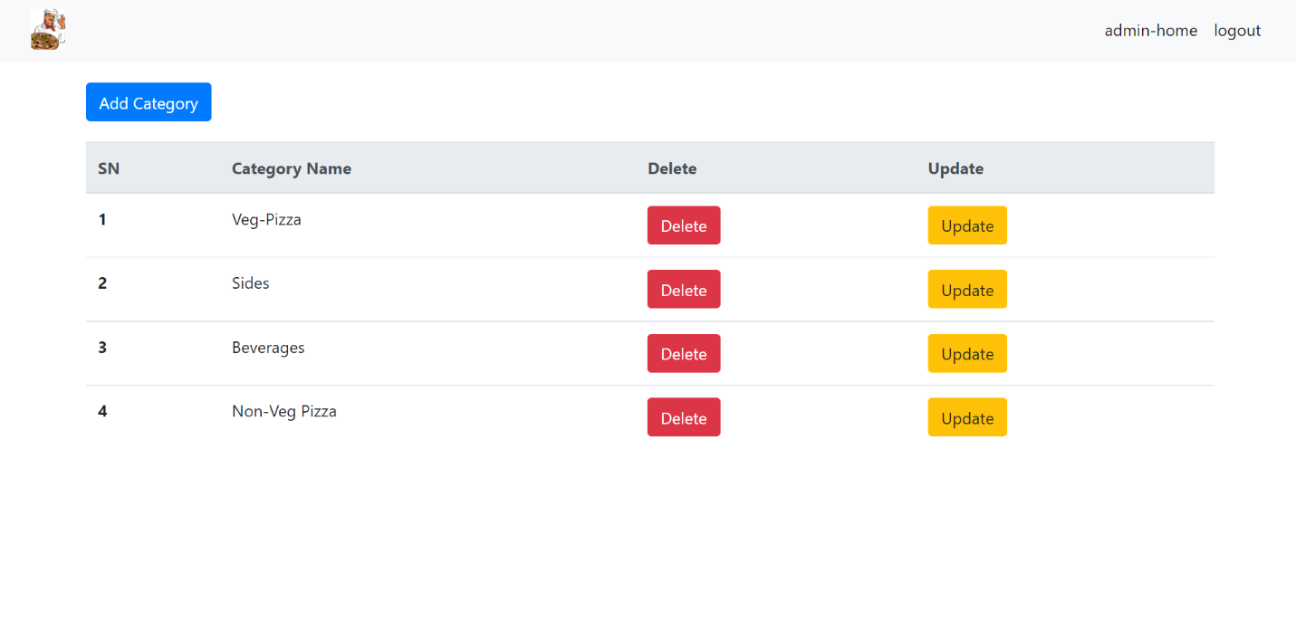

* If you click manage in the products section, you can add, delete and update different product. 